NETWORK DIAGRAM

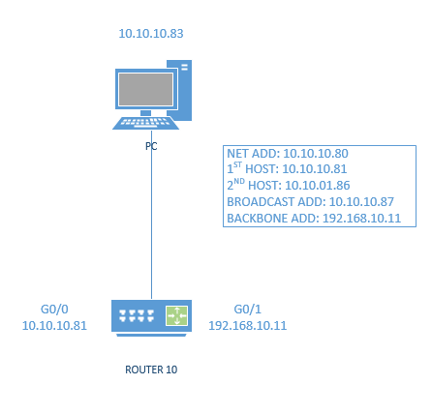

DESCRIPTION OF RACK EQUIPMENT

* What type of equipment: router, switch, rackmount console, power supply, security appliance
* Vendor names & model numbers(if available):
* Router – CISCO, 2911
* Rackmount console – TRIPP-LITE, B021-000-19-SH
* Switch – CISCO
* Security appliance – CISCO, ASA 5510
* Router interfaces
* Fast Ethernet
* 3 Gigabit Ethernet
* Console Port
* Aux Port
* 2 Usb ports
* 1 2.0 Usb port
* Switch interfaces
* 24 ports
* 1 2.0 Usb port

PROCEDURE USED TO CREATE NETWORK:

We began by plugging the power cable from the main power supply for the rack into an outlet on the wall or under the lab table and switch it on. Next, after the equipment powers up, we connect one end of a console cable (blue) to the console port of the top ***router*** and the other end to the serial port in the back of a PC. We do this in order to configure Putty to connect to our router, and open a connection. Now we configure the ip addresses for our subnets (private and public/backbone) on two of the interfaces and start the interfaces.

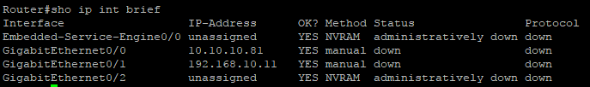

Then we cable our router to our switch, specifically using port 4 here, we used one of the shorter cables here. Then using an RJ-45 cable from the supply of cables in the classroom we plug it into the network card in the back of the PC. We also changed the ip address of the ***‘Local Area Connection’*** physical interface on our PC to a host address on our “private” subnet.

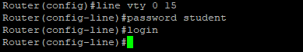

In other words, we set a ‘static’ ip address. Finally for the first part of this project we cable the PC to the switch, using port 5, and test our IP address using ping and telnet.

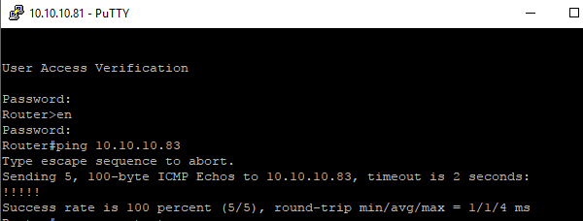

The first thing we did for the second part of our configuration was switch from telnet to SSH instead.

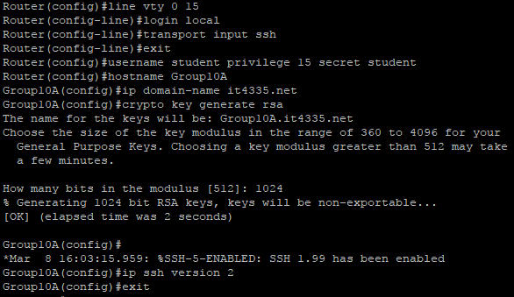

Now we change the ip address of the ***‘Local Area Connection’*** physical interface on the PC to a host address on our “private” subnet. In other words, we set a ‘static’ ip address along with a subnet mask. We also set the ‘default gateway’ with our router’s ip address on this subnet.

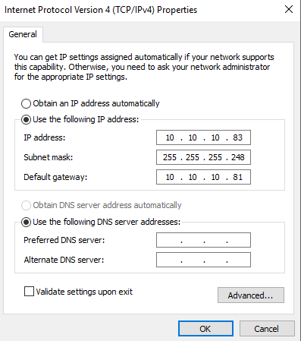

We then grab an Ethernet cable and connect the NIC on the PC to the switch (port #5) we used in Part 1. Next we ping the IP address of the PC from the router console to make sure we have connectivity. Then we use Putty to ‘SSH’ into the router. We also created a second interface on our router that allows all the routers in the room to connect to each other to route traffic from one subnet to another, a ‘public’ network or the ‘backbone.’

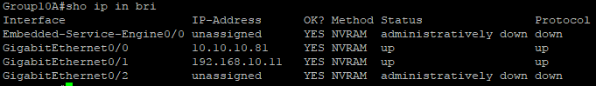

Now we need to run a cable from the physical ‘backbone’ interface we configured on the router to one of the ‘white’ physical Ethernet ports. Now we set up a routing protocol on our router, and configure RIP as we did with GNS3.

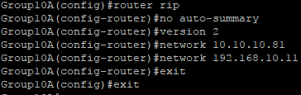

Finally we ping our used addresses in order to make sure we have connectivity.

